Student Enrollment and graduation rates in US Universities.

Introduction:
The objective of this case analysis is to assess U.S. News and World Report’s College Data and develop a model which will forecast likelihood of enrollment of a student in a university. We care about this data because nowadays there are huge number of universities have been establishing with new courses and it’s important that they should be aware of the key factors which student mostly consider enrolling. This exploratory analysis will help both the student and universities.

Dataset:
The dataset we chose contains US universities undergraduate’s data. This dataset has
been picked from Kaggle website. This data has been collected by StatLib library which is maintained at Carnegie Mellon University since the year 1995. The data set has 776 observations and 17 variables. The meta data is described below,

Variable Name | Meta data
College Type | Indicates whether private or public university
Apps | Number of applications received
Accept | Number of applications accepted
Enroll | Number of new students enrolled
Top10perc | Percent of new students from top 10% of H.S. class
Top25perc | Percent of new students from top 25% of H.S. class
F.Undergrad | Number of fulltime undergraduates
P.Undergrad | Number of part time undergraduates
Outstate | Out-of-state tuition fee
Room.Board | Room and board costs
Books | Estimated book costs
Personal | Estimated personal spending
PhD | Percent of faculty with Ph.D.’s
Terminal | Percent of faculty with terminal degree
perc.alumni | Percent of alumni who donate
Expend | Instructional expenditure per student
Grad.Rate | Graduation rate

Based on the universities data, we chose to explore the factors that play an important role in student enrollment and graduation rate.

Some of the variables we intend to study are:

Variable Name | Variable Type
College Type | Categorical
Enroll | Numeric
Grad.Rate | Numeric
Outstate | Numeric
PhD | Numeric
Top25perc | Numeric
F. Undergrad | Numeric
P. Undergrad | Numeric

What factors contributed in universities enrollment (i.e. Enroll) ?
College Type : This field has a big effect in the decision to enroll due to the level of cost for the private ones.
Outstate tuition fee: we believe that outstate tuition fee might have an effect on-student enrollment.
PhD: This variable says about Number of professors with PhD degree and we plan to study this variable as this will have an effect in new student enrollment.
F. Undergrad: We observed that Number of full time under graduates currently studying in the university may influence student enrollment.
What factor influences the graduation rate (i.e. Grad.Rate) ?
F.Undergrad: We observed that total no. of full-time under graduates will impact the graduation rate.
P.Undergrad: We observed that total no.of part-time under graduates will impact the graduation rate.
Top25perc: We believe Top25 % of students joined in a university will influence the graduation rate.
Methodology:
As we don’t have any missing values or inconsistent data it doesn’t require preprocessing. Hence, the data is ready for analysis and interpretation. So, we will use descriptive statistics for summarizing the data and exploratory data analysis to check relationship between the variables. Further, we will find the correlation and choose the model that best suits for predictive analysis.
Exploratory data analysis:
Exploratory Data Analysis is starting without any a priori hypotheses and we usually do it using graphs by looking at simple relationship between the variables.
Descriptive statistics is to summarize the data for easy understanding and comparing.
Finding the descriptive statistics for the below numerical variables and observing the patterns.
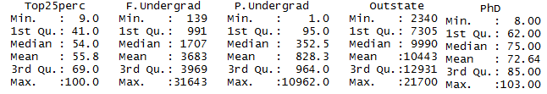
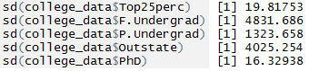
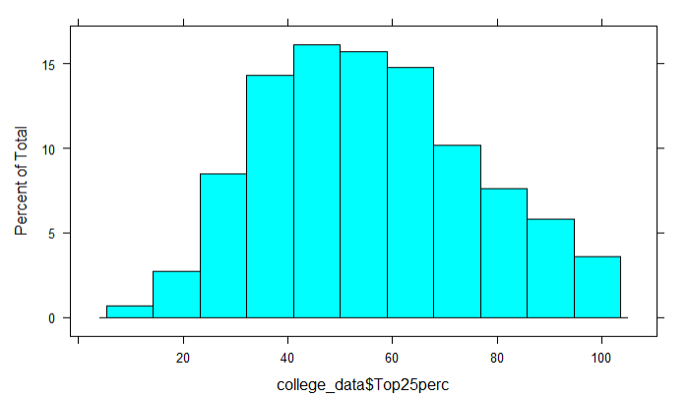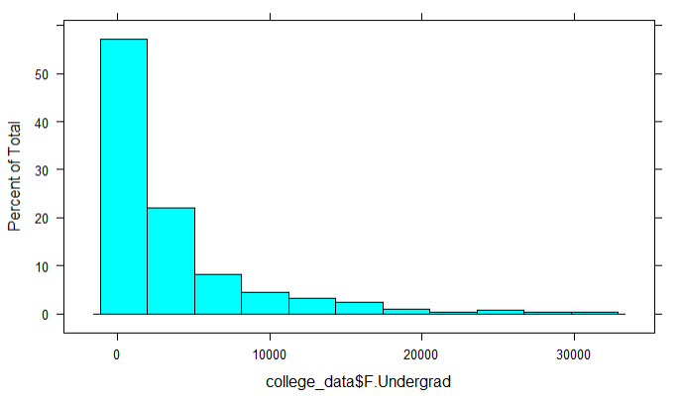
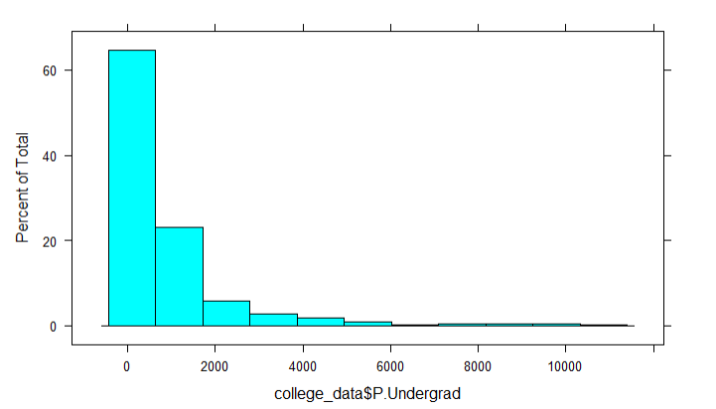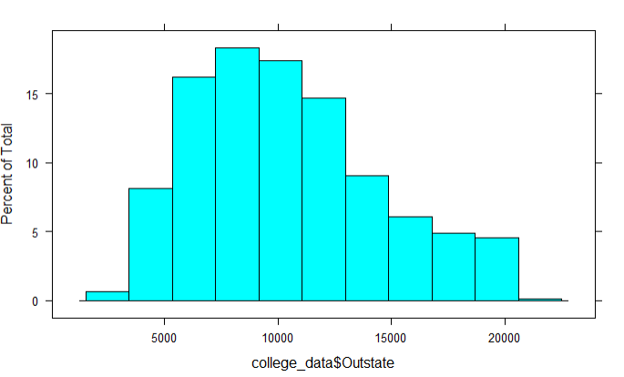

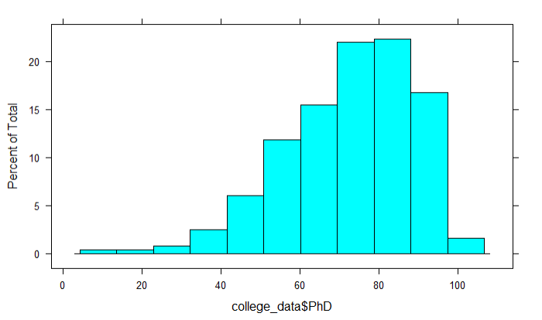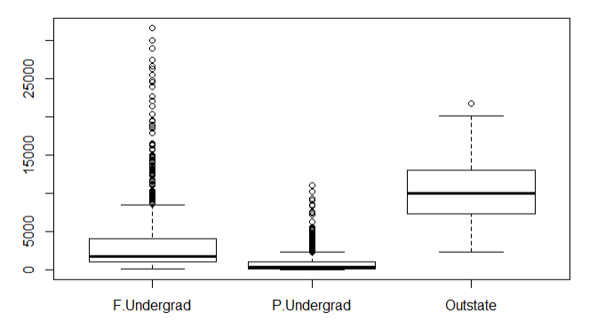
Inferences about the Descriptive statistics:

- Based on summary statistics we can infer mean, median and Range for the variables.
- Top25perc: The skewness is 0.27 and it is fairly symmetric.
- F.Undergrad: The skewness is 1.2 and it is positively skewed.
- P.Undergrad: The skewness is 1.07 and it is positively skewed.
- OutState: The skewness is 0.3 and it is fairly symmetric.
- PhD: The skewness is - 0.4 and it is fairly symmetric.
- Outliers in a data can distort predictions and affect the accuracy if we don’t detect and handle them appropriately. By using box plot we can infer that the variables F.Undergrad and P.Undergrad has extreme outliers.
Finding the Relationship between response and exploratory variable using XY plot:
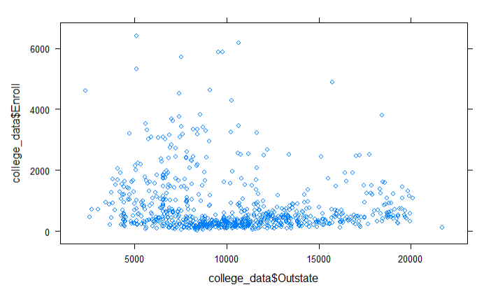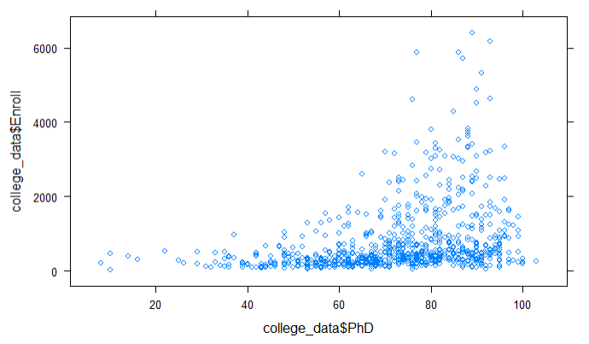
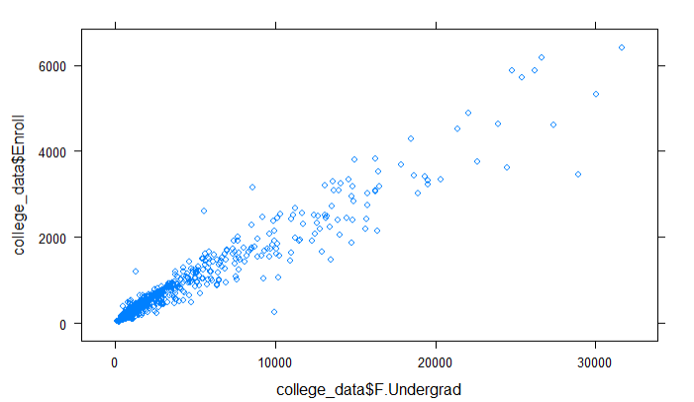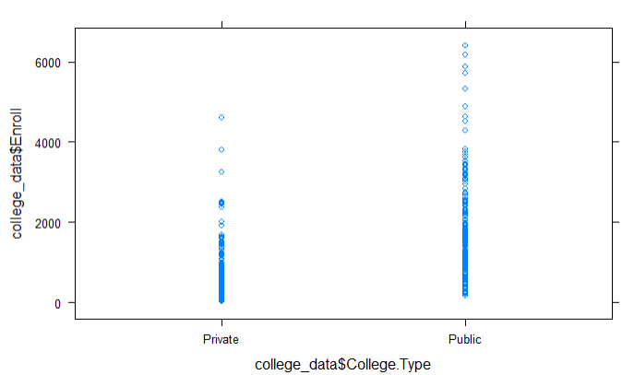
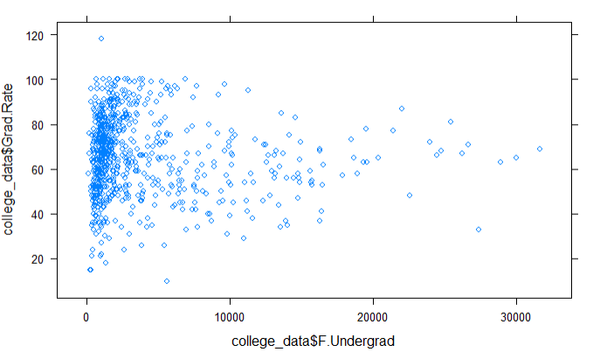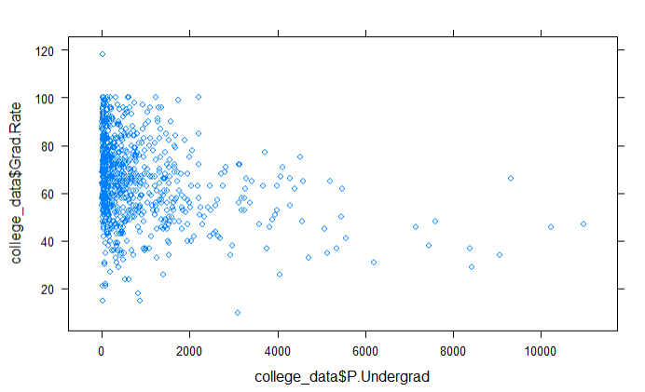
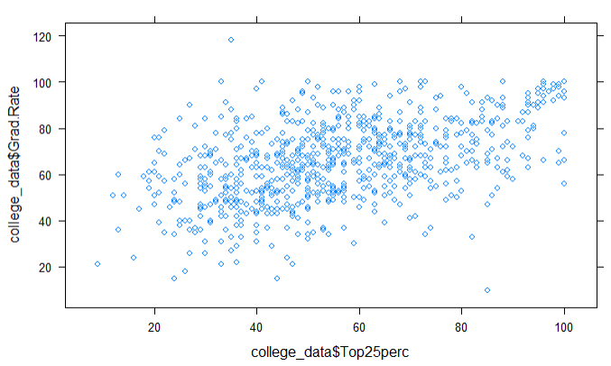
From the above graphs we can infer the following facts,
Response_Variable | Direct Relationship | Inverse Relationship
Enroll | PhD, F.Undergrad | Outstate
Grad.rate | Top25perc | F.Undergrad, P.Undergrad

Conclusion:
In Exploratory analysis we identified the influencing variables that affect student enrollment and graduation rate. In addition, it is observed that the variables F.Undergrad and P.Undergrad are not normally distributed. Since data mining models expect data to be normally distributed, we need to do transformations to achieve normality, this can be done using any of the following:
  - Log transformation
  - Square root transformation
  - Reverse square root transformation.
After transforming to normality, we will proceed with establishing correlation and by then build a model for predictive analysis in Phase 2.

